**ASSIGNMENT 1 FRONT SHEET**

|  |  |  |  |
| --- | --- | --- | --- |
| **Qualification** | **BTEC Level 5 HND Diploma in Computing** | | |
| **Unit number and title** | **Unit 3: Professional Practice** | | |
| **Submission date** | 22/02/2022 | **Date Received 1st submission** |  |
| **Re-submission Date** |  | **Date Received 2nd submission** |  |
| **Student Name** | 1.Do Huu Duy  2.Nguyen Nhat Chinh  3.Huynh Quoc Tuan  4.Truong Quang Minh  5.Luu Pham Anh Kiet | **Student ID** | 1.GCC200018  2.GCC200312  3.GCC200311  4.GCC200321  5.GCC200083 |
| **Class** |  | **Assessor name** | Michael Omar |
| **Student declaration**  I certify that the assignment submission is entirely my own work and I fully understand the consequences of plagiarism. I understand that making a false declaration is a form of malpractice. | | | |
|  |  | **Student’s signature** | Duy, Chinh, Tuan, Minh, Kiet |

**Grading grid**

|  |  |  |  |  |  |  |  |  |
| --- | --- | --- | --- | --- | --- | --- | --- | --- |
| P1 | P2 | P3 | P4 | M1 | M2 | M3 | D1 | D2 |
|  |  |  |  |  |  |  |  |  |

|  |  |  |
| --- | --- | --- |
| **❒ Summative Feedback: ❒ Resubmission Feedback:** | | |
| **Grade:** | **Assessor Signature:** | **Date:** |
| **Internal Verifier’s Comments:** | | |
| **Signature & Date:** | | |

**ASSIGNMENT 1 BRIEF**

|  |  |  |  |
| --- | --- | --- | --- |
| **Qualification** | **BTEC Level 5 HND Diploma in Computing** | | |
| **Unit number** | Unit 3: Professional Practice | | |
| **Assignment title** | Planning an SDP Event | | |
| **Academic Year** | 2022 | | |
| **Unit Tutor** |  | | |
| **Issue date** | **7th January 2022** | **Submission date** |  |
| **IV name and date** |  | | |

|  |
| --- |
| **Submission format** |
| **Part 1: Requirements**  The submission should be made in the form of a completed individual portfolio folder, which includes all the tasks outlined in the Assignment Brief. Although this assignment requires collaborative work, each student must submit an individual portfolio folder.  **Part 1: Produce** a five-day professional event schedule (using project management software) and WBS (work breakdown structure) prior to the five-day development event that details planning and resource allocation including the (Responsibility Assignment Matrix)  **Part 2:** Create a ten-minute PowerPoint presentation on 'team dynamics' that includes a presentation and an activity sheet that requires delegates to participate in a team-building activity. (Maximum of eight slides, including the introductory slide)  **Part 3:** A written evaluation of your performance in this task and your contribution to the team.  You are required to make use of **headings,** **paragraphs,** **subsections, and illustrations as appropriate**, and all work must be supported with research and **referenced using the Harvard referencing system**. The recommended word limit is 500–1,000 words, although you will not be penalized for exceeding the total word limit. |

|  |
| --- |
| **Assignment Brief and Guidance** |
| You have been tasked with the responsibility of overseeing the development of an e-commerce solution for a Fortune 500 company. As a member of the development team, you will develop a plan, basing on the SDP (software development plan) that will be distributed to internal employees and stakeholders within the organization in which you work.  You will develop a professional plan for this upcoming project by simulating real-world events, meeting locations, agendas, feasibility reports, and associated costs.  **NOTE**: “*You do not carryout real meeting in the venue but must get actual quotes of prices and facilities in real life.*”  You are expected to conduct thorough research on venue costs, transportation costs (if the project takes place outside of the city), and team member feeding and lodging.  Assuming you have an experienced team of designers and developers, the development process is estimated to take no more than five days.  The following is a description of SDP.  The Software Development Plan (SDP) is a document that describes how a developer intends to proceed with a software development effort. The SDP provides insight into and a tool for monitoring software development processes to the acquirer. Additionally, it details the procedures to be followed and the approach to be taken regarding each activity, organization, and resource. The SDP's purpose is to communicate to team members and stakeholders how a program's software will be developed and how a Program Manager will allocate direct resources.  **Working in small groups (3-4 per group):**  **Part 1.** Produce a professional event schedule (using project management software) and WBS (work breakdown structure) prior to the five-day development event that details planning and resource allocation including the (Responsibility Assignment Matrix)  **Part 2.** Create a ten-minute PowerPoint presentation on 'team dynamics' that includes a presentation and an activity sheet that requires delegates to participate in a team-building activity. (Maximum of eight slides, including the introductory slide)  **Working individually:**  **Part 3** Produce a written team evaluation of the effectiveness and application of interpersonal skills during the design and delivery process. You should also include a self-evaluation of your performance in this project and your contribution to the team you worked in. Explain what skills and qualities you gained from this project and what values you added to your development plan.  Identify the problems and produce a report discussing problem-solving and its importance in planning and running a development event. Your essay should include a discussion of various problem-solving techniques and justify the solution methodologies used during your project. You should also have a critique of the application of critical  **Part 3: Learning outcomes: LO1, LO2** |

|  |  |  |  |
| --- | --- | --- | --- |
| Assessment Criteria | | | |
| Pass | Merit | | Distinction |
| **LO1:** Demonstrate a range of interpersonal and transferable communication skills to a target audience | | | |
| **P1** Demonstrate the use of 3 different communication style within your team.  Discuss the purpose of a Software Development with its objectives.  **P2** Demonstrate that you have used effective time management skills in planning an event. | | **M1** Design a professional schedule to support the planning of an event, to include contingencies and justifications of time allocated. | **D1** Evaluate the effectiveness and application of interpersonal skills during the design and delivery of a training event. |
| **LO2** Apply critical reasoning and thinking to a range of problem-solving scenarios | | | |
| **P3** Demonstrate the use of different problem-solving techniques in the design and delivery of an event. | | **M2** Research the use of different problem-solving techniques used in the design and delivery of an event. | **D2** Critique the process of applying critical reasoning to a given task/activity or event. |
| **P4** Demonstrate that critical reasoning has been applied to a given solution. | | **M3** Justify the use and application of a range of solution methodologies. |  |

Table of Contents

1.INTRODUCTION 7

2.DEMONSTRATE, USING DIFFERENT COMMUNICATION STYLES AND FORMAT, THAT YOU CAN EFFECTIVELY DESIGN AND DELIVER A TRANING EVENT FOR A GIVEN TARGET AUDIENCE (P1) 7

2.1. Definition and the importance of communication skill 7

2.1.1. Definition of communication skill 7

2.1.2. Importance of communication skill 7

2.1.3. Verbal communication 9

2.1.4. Non-verbal communication 10

2.2. Communication in my group 10

3. DEMONSTRATE THAT YOU HAVE USED EFFECTIVE TIME MANAGEMENT SKILLS IN PLANNING AN EVENT (P2) 11

3.1 Definition and the importance of time management skill 11

3.1.1 Definition of time management skill 11

3.1.2 Importance of time management skill 12

3.2 Planning a training event (group work) 13

3.2.1 Name of the training program 13

3.2.2 Goals of the training program 13

3.2.3 Participants 13

3.2.4 Time 14

3.2.5 Place 14

3.2.6 Agenda 14

3.2.7 GANTT chart 15

3.2.8 Estimated Budget 15

3.2.9 PowerPoint Slides for session 16

3.2.10 Speaker notes 16

4. DEMONSTRATE THE USE OF DIFFERENT PROBLEM-SOLVING TECHNIQUES IN THE DESIGN AND DELIVERY OF AN EVENT (P3) 17

4.1 Definition and the importance of problem solving 17

4.1.1 Definition of problem solving 17

4.1.2 Importance of problem solving 17

4.2 Some techniques and tools for the problem solving 18

4.2.1 Some techniques for the problem solving 18

4.2.2 Some tools for the problem solving 18

4.2.3 Six Thinking Hats 21

4.3. Problems and solutions in the training event 22

5. DEMONSTRATE THAT CRITICAL REASONING HAS BEEN APPLIED TO A GIVEN SOLUTION (P4) 23

5.1. Definition and the importance of critical reasoning 23

5.1.1 Definition 23

5.1.2. Importance 24

5.2. Apply to a given solution 24

6. PERFORMANCE EVALUATION 25

6.1. Team member’s roles 25

6.2. My contribution 25

7. Conclusion 26

8. Critical evaluation 26

References 29

# 1.INTRODUCTION

We are group members of the FPT Education Department. We were tasked with organizing an event about “Training about Information Technology and Soft Skill”. The event is aimed at new students entering the school, training the necessary skills for students to understand and equip themselves. Event participants include students, management, and event organizers. The event lasted 5 days. This report consists of 8 parts, part 1 is the introduction part, I will introduce each part about our report. part 2: we will cover the basic skills such as communication skills, teamwork skills. part 3: we will talk about the importance of time management skills and recommend a training program. part 4: we will talk about the importance of problem-solving and some techniques and tools for problem-solving. part 5: we will talk about the importance of critical reasoning. part 6: we will evaluate the performance of the members in the group. part 7: we will conclusion. part 8: we will evaluate the strengths and weaknesses of each member in the group and the given score our group wants in this report.

# 2.DEMONSTRATE, USING DIFFERENT COMMUNICATION STYLES AND FORMAT, THAT YOU CAN EFFECTIVELY DESIGN AND DELIVER A TRANING EVENT FOR A GIVEN TARGET AUDIENCE (P1)

## 2.1. Definition and the importance of communication skill

### 2.1.1. Definition of communication skill

The process of communication is what allows us to interact with other people; without it, we would be unable to share knowledge or experiences with anything outside of ourselves. Common forms of communication include speaking, writing, gestures, touch and broadcasting (meterial, 2022)

Communication skills are the abilities you use when giving and receiving different kinds of information. Some examples include communicating new ideas, feelings or even an update on your project. Communication skills involve listening, speaking, observing and empathising. It is also helpful to understand the differences in how to communicate through face-to-face interactions, phone conversations and digital communications like email and social media (indeed, 2021)

Communication skills are all the skills that help people connect with others and build and maintain interactions. They involve speaking, listening, observing, and empathizing (resumelab, 2022)

### 2.1.2. Importance of communication skill

* Importance of Communication Skills in Life

Good communication skills in life will ensure everyone around you understands you and you understand them. You will be confident and assertive. There will be less misunderstanding and you will rarely have to face issues that come with poor communication:

* It will be easy for you to make and keep friends
* You will have a good relationship with your spouse, kids, family members, and friends
* Your daily functioning will be at its optimal best
* Your daily chores and errands will also happen at their optimal best
* You will have less stress because poor communication also leads to a lot of mental stress.
* Importance of Communication Skills for Students

One of the biggest reasons why many students suffer is because of poor communication skills. It affects their functioning in schools and colleges and also affects their ability to understand what the teacher is teaching. Hence, as a student, you need to develop your communication skills because:

* It will help you communicate with teachers on things you have a tough time understanding
* It will help you build relationships with your fellow students
* Your grades will improve as these skills help with studying and revision
* You will be able to study subjects you like by convincing your parents to let you study for the career you want
* You will have much less mental stress compared to other students only because you are a better communicator.
* Importance of Communication Skills for Professionals

The workplace is the most commonplace for miscommunication, and it could have serious repercussions on your career. Therefore, as a professional, you need to have excellent communication skills. They will also help you in

* Doing your job well. Good communication skills have a direct impact on how well you perform
* Develop yourself as a leader in the workplace which will bring in opportunities to grow and move up
* Build good relations and camaraderie with all your fellow employees
* Naturally, command respect from your colleagues and even your bosses Improved body language
* Zero to minimal professional life stress as you will be doing well.
* Importance of Communication Skills for Teachers

Teaching is one of the most responsible professions in the world. A country with good teachers will always be on the fast track of development, as teachers are the ones who hone talent. Therefore, if you are in this noble profession, or are thinking of getting into this profession, you need to have excellent communication skills for the following reasons

* To communicate with the students better. Students, who connect with their teachers well, understand them better and do well in the subjects they teach
* Command respect of your students. Teachers who are excellent communicators are well-respected by the students
* Youll have the ability to get through students who have learning issues. Each student is different, so sometimes, there are students with whom you have to communicate differently for them to be able to learn from you
* Make a difference to the lives of students as in most cultures, teachers hold the position of mentors and parent-like figures
* Do well in your profession with many opportunities for promotions and a high salary.
* Importance of Communication Skills in Business & Organization

Businesses and organizations are places where communication skills are required the most. In a business or organization, there are so many departments that have to function like a well-oiled machine. Communication is the key. There are many other reasons as well as to why communication skills are required in a business and organization

* Marketing, advertising, and sales are the departments that have to be excellent in communication. Their success will ensure products and services are sold resulting in profits
* Excellent communication helps not just get new customers but also helps you retain them and make them loyal customers. A majority of the profits come from retained customers
* Building your business or organizations brand also requires good communication skills. Only then will be able to build a brand that has reputation and value
* Another advantage of good communication skills is being able to create communication for businesses or organizations. Many businesses have trouble with this and end spending money on professional communication creators (IBMR, 2020)

### 2.1.3. Verbal communication

Verbal communication is the act of sharing information between individuals by the use of speech. Any interaction that makes use of spoken words is considered as verbal communication. It is an integral part of the business world. Oral communication used within an organization includes personal discussions, staff meetings, telephone discourse, formal and informal conversations and presentations (cleverism, 2022)

Verbal communication is defined as communication to express our views, information, and ideas in the form of sound and words. The spoken part usually involves face-to-face communication. and when people ponder the word communication, they often think about the act of talking (getuplearn, 2021)

Verbal communication means effectively presenting your thoughts in verbal format i.e., by talking. Verbal communication skills are essential in the world of business. Be it a weekly meeting or presentation to stakeholders, the importance of verbal communication is unparalleled. People always remember a person who speaks clearly, effectively, confidently, and charismatically (harappa, 2021)

### 2.1.4. Non-verbal communication

Nonverbal communication is the transmission of messages or signals through a nonverbal platform such as eye contact, facial expressions, gestures, posture, and body language. It includes the use of social cues, kinesics, distance and physical environments/appearance, of voice and of touch. It can also include the use of time and eye contact and the actions of looking while talking and listening, frequency of glances, patterns of fixation, pupil dilation, and blink rate (wikipedia, 2022)

Non-verbal communication is the transfer of information through the use of body language including eye contact, facial expressions, gestures and more. For example, smiling when you meet someone conveys friendliness, acceptance and openness. Everyone uses nonverbal communication all the time whether they know it or not. Nonverbal communication is dependent on seeing and analyzing physical movements as opposed to verbal communication, or the use of language to transfer information through written text, speaking or sign language (indeed, 2021)

Non-verbal communication is the process by which someone uses facial expressions, gestures or body positioning (body language) to directly or indirectly communicate their feelings toward a person, idea or situation. Non-verbal communication can be displayed through gestures and expressions during a verbal interaction to unconsciously express one’s true thoughts about the conversation. Or, non-verbal signals can be displayed simply when someone is not actively engaged in a conversation that they should be participating in (resume, 2021)

## 2.2. Communication in my group

When the epidemic stabilized and life returned to a new normal, our group returned to school to meet each other which it was easier to communicate with each other. We communicate with each other verbally and non-verbally

Communicate directly: We communicate directly with each other at school to divide tasks for each team member, discuss and clarify the requirements of the assignment together

Communicate indirectly: We communicate indirectly with each other using social media to help members in the group to handle difficulties while doing their tasks

• Advantages of communicate directly

* Members can see each other
* We can aware the members by their facial expressions to know they understood the content during the discussion or not
* Easier to communicate with each other

• Disadvantages of communicate directly

* The members in group can be easily distracted and unable to concentrate
* Negative things happen when members disagree about something and they can talk negatively with each other when they see someone else’s face uncomfortable about their opinion

• Advantages of communicate indirectly

* They won’t be distracted or unable to concentrate because they don't see each other and won't mention unrelated things
* It can be more flexible

• Disadvantages of communicate indirectly

* It’ll lost lots of time
* difficulty to aware the members understand or not because we can't see them when using messages to talk with each other, sometimes they will still say “OK” when they don't understand the problem.

• Advantages of verbal communication

* Don’t waste lots of time
* It's easier to explain things with words instead of texting

• Disadvantages of verbal communication

* We speak too fast and the members of the group may not be able to keep up
* Difficulty to explain to each other when we lack of vocabulary

• Advantages of non-verbal communication

* Emphasize important points to help members in the group understand
* Making members in the group happy and motivated when we make positive gestures during the discussion

• Disadvantages of non-verbal communication

* Some gestures may provoke the members in the group
* Take a long time to express opinions

# 3. DEMONSTRATE THAT YOU HAVE USED EFFECTIVE TIME MANAGEMENT SKILLS IN PLANNING AN EVENT (P2)

## 3.1 Definition and the importance of time management skill

### 3.1.1 Definition of time management skill

Time management is the process of organizing and planning how to divide your time between different activities. Get it right, and you'll end up working smarter, not harder, to get more done in less time – even when time is tight and pressures are high (mindtools, 2021)

Time management is the strategy of planning out your available time and controlling the amount of time you spend on specific tasks in order to work more efficiently (freshbooks, 2022)

According (Team, 2021), Time management skills are those that help you use your time effectively and achieve desired results. Time management skills can help you allocate your time properly and accomplish tasks efficiently. Some of the most important skills related to successful time management skills include:

* Organization
* Prioritization
* Goal setting
* Communication
* Planning
* Delegation
* Stress management
* Flexibility

### 3.1.2 Importance of time management skill

According (Panigrahi, 2022), Time management plays a significant role in a student’s life enabling them to learn more at a faster pace. Every student tends to finish a particular set of curriculum within a fix time period of either a year or semester. Managing the academics, projects, assignments, along with exam preparation for the term can be a stressful job for many young learners. Unable to divide the time equally for every topic of the subjects, students often opt for last-minute preparation which not only makes them scoreless but also obstructs their learning capability. By recognizing the worth of time and utilizing it effectively to focus on the goal, we can achieve a lot more with fewer efforts. A successful student is only different from the rest of the mass because of his/her time management skills. These skills not only enhance our decision making capability but also aids in becoming successful by taking control of your life. Proper time management not only eliminates the negative features such as stress and anxiety but propels us to contemplate more on learning and thriving. Still one of the unsolved mysteries for many students, here are some points which will help the students in managing time successfully:

* Stamp out of distractions: With limitless lucrative issues to deviate the focus of young students, staying away from distractions can be a tough job. After setting the goal, eradicate anything that comes in between you and your success, let it be phone, movie, or any other kind of amusement
* Sustain concentration: Focus matters the most in everyone’s life and is considered as the deciding factor for achieving success. Doing a job with attention and sincerity not only improves the rate of succession but also molds us as a better professional. Apart from education or examinations in academics, a strong concentration power helps us in every aspect of life in the future also
* Use calendar and checklists: Tracking record of the job which already been done and the remaining jobs left unattended can save a lot of time. Instead of planning it all at the last minute, it is always better for us to make a schedule of everything that is needed to be done. By allotting a stipulated time period for a particular piece of work, we not only tend to finish it on time but also can keep track of jobs that remained unattained
* Stay organized: An organized mindset and environment contribute a lot to the effective work style. Having proper planning beforehand and scheduling your timetable along with it can work like a charm. A disorganized mindset will often lead to creating ruckus at the last minute which may spoil the essence of the job
* Set your priorities straight: By sticking on to the schedule, divide the goal into smaller segments and try achieving it within a stipulated period of time. Every time after a small achievement of objective reward yourself for further motivation. These small indulgences are not to deviate you from the path but to encourage and energize you to move further
* Take a self break: A Proper sleep and a little break from the monotonous lifestyle is necessary for everyone's hectic work pressure will make us dull and discourage us to work further.

## 3.2 Planning a training event (group work)

### 3.2.1 Name of the training program

We will make event named **“Training about Information Technology and Soft Skill”.** The event will begin at 7:30am February 20, 2022 and end February 24, 2022. On Information Technology training, we will train on "Database Design" and about Soft Skill training, we will train on "Communication Skill" and "Time Management skill".

### 3.2.2 Goals of the training program

We conduct this event with the aim of training students to understand the importance of soft skills and helping them equip themselves with important skills. We train in Database Design to give students an overview of this subject, helping them understand the basics of this subject so that they can be more solid when studying the subject at the specialized stage. This program is organized for K10 students majoring in Information Technology.

### 3.2.3 Participants

K10 students majoring in Information Technology (100 people), speaker (2 people) and event managers include Do Huu Duy, Luu Pham Anh Kiet, Nguyen Nhat Chinh, Truong Quang Minh, Huynh Quoc Tuan.

### 3.2.4 Time

From February 20, 2022 to February 25, 2022

### 3.2.5 Place

Hall of FPT Education

### 3.2.6 Agenda

|  |  |  |  |  |  |
| --- | --- | --- | --- | --- | --- |
| **Date** | **Time** | **Place** | **Work** | **Performer** | **Manager** |
| 20/2/2022 | 7:30 – 8:00 | Hall 5th floor | Attendance | 1st Speaker | All members |
| 8:00 – 10:30 | - The speaker introduces the subject in the training program (Database Design)  - Sharing experiences, motivating students |
| - The speaker introduces the subject in the training program (Soft Skill)   * Time Management Skill * Communication Skill   - Sharing experiences, motivating students | 2nd Speaker |
| 10:30 – 10:40 | Lucky draw |
| 21/2/2022 | 7:30 – 8:00 | Hall 5th floor | Attendance | Lecturer: Nguyen Hung Dung | Minh |
| 8:00 – 10:30 | 1. Training about Database Design  * Introduction * Data and Database * File-based systems  1. Mini game |
| 10:30 – 10:40 | Lucky draw |
| 22/2/2022 | 7:30 – 8:00 | Hall 5th floor | Attendance | Lecturer: Nguyen Hung Dung | Duy |
| 8:00 – 10:30 | 1. Training about Database Design  * Normalization * Some Key concepts * Properties of relation  1. Mini game |
| 10:30 – 10:40 | Lucky draw |
| 23/2/2022 | 7:30 – 8:00 | Hall 5th floor | Attendance | Lecturer: Tran Thi Anh Phuong | Kiet |
| 8:00 – 10:30 | 1. Training about Time Management Skill  * Definition * The importance of time management skill * Effective time management tips  1. Mini game |
| 10:30 – 10:40 | Lucky draw |
| 24/2/2022 | 7:30 – 8:00 | Hall 5th floor | Attendance | Lecturer: Tran Thi Anh Phuong | Chinh |
| 8:00 – 10:30 | 1. Training about Communication skill  * Definition * The importance of communication skill * Effective communication tips  1. Mini game |
| 10:30 – 10:40 | Lucky draw |
| 25/2/2022 | 7:30 – 8:00 | Hall 5th floor | Attendance | Tuan | Remaining 4 members |
| 8:00 – 10:20 | - Summarize what was created in the event  - Check whether the students have mastered the knowledge or not by dividing into groups to do exercises |
| 10:20 – 10:40 | - Giving awards for lucky students  - Giving certificates to students who participate 70% or more of the event time |

### 3.2.7 GANTT chart

Send email notifications to students about the event (14/2/2022)

Prepare for the event (14/2/2022 – 19/2/2022)

### 3.2.8 Estimated Budget

|  |  |  |  |  |
| --- | --- | --- | --- | --- |
| **Item**  **(1)** | **Quantity**  **(2)** | **Price (VND)**  **(3)** | **Date**  **(4)** | **Total (VND)**  **(2)x(3)x(4)** |
| Lucky price | 1 | 100.000 | 4 days | 400.000 |
| Mini-game price | 1 | 20.000 | 4 days | 80.000 |
| Water | 110 bottles | 10.000 | 6 days | 6.600.000 |
| Cake | 110 pieces | 10.000 | 6 days | 6.600.000 |
| Speaker | 2 people | 1.000.000 | 1 days | 2.000.000 |
| Lecturers | 2 people | 1.000.000 | 4 days | 8.000.000 |
| Total | 23.680.000 | | | |

Cost to carry out the event we are supplied by the FPT Education with total of money 25000000 VND. Total cost that we spent in the event is 23680000 VND and the remaining balance we have sent back for the FPT Education.

### 3.2.9 PowerPoint Slides for session

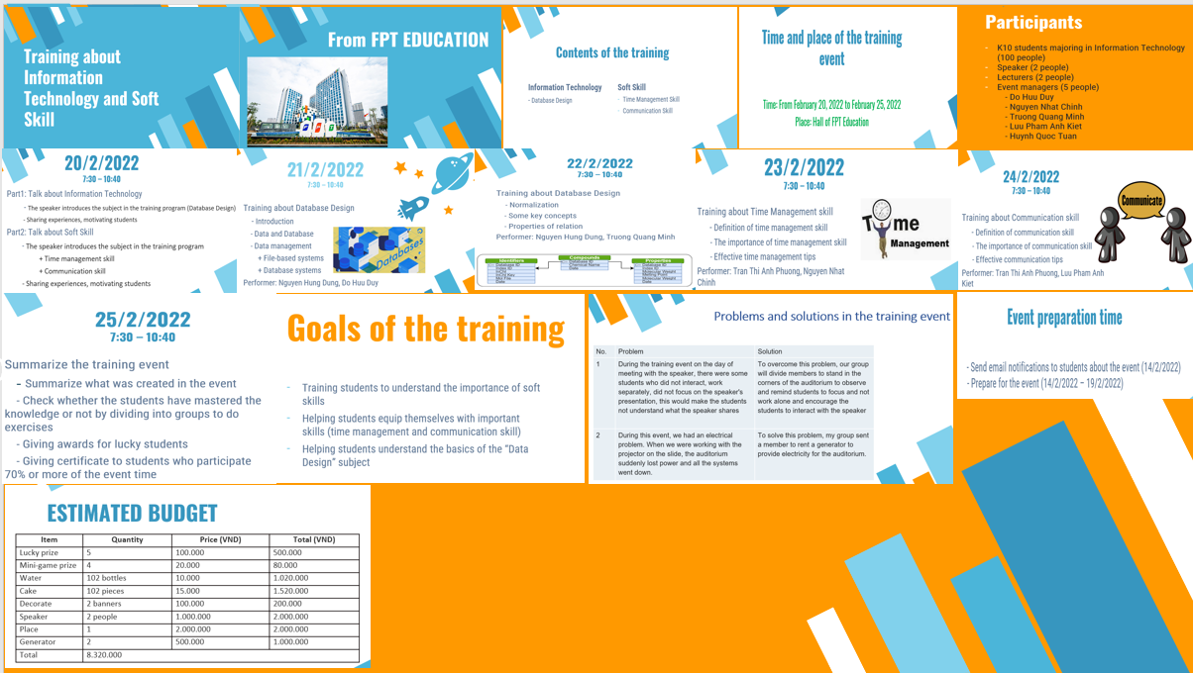

### 3.2.10 Speaker notes

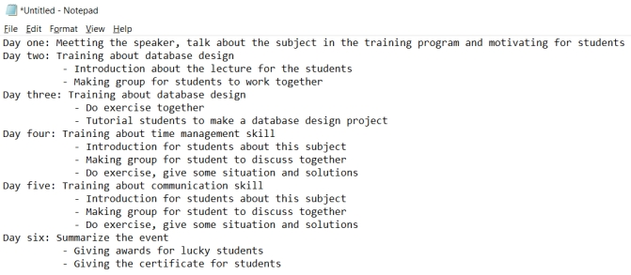

# 4. DEMONSTRATE THE USE OF DIFFERENT PROBLEM-SOLVING TECHNIQUES IN THE DESIGN AND DELIVERY OF AN EVENT (P3)

## 4.1 Definition and the importance of problem solving

### 4.1.1 Definition of problem solving

Problem-solving is a process for individuals to overcome a specific problem. That process, simply, begins at a starting point and continues until a conclusion is reached. The process includes higher mental functions and creative thinking (M.S Sam, 2022)

Problem-solving is a process of solving any kind of problem. This process is acted upon in some steps. These steps start from identifying the problem and determining the cause of the problem. After the problem and its cause are identified, the next step is to select alternatives for the solution and implement the solutions. All of these steps are collectively known as a problem-solving process (instagantt, 2022)

Problem-solving is a process of recognizing a problem, defining it, identifying alternative plans to resolve the problem, selecting a plan, organizing steps of the plan, implementing the plan, and evaluating the outcome; a performance component of occupational therapy (medical-dictionary.thefreedictionary, 2022)

### 4.1.2 Importance of problem solving

Problem-solving is at the core of human evolution. It is the method we use to understand what is happening in our environment, identify things we want to change and then figure out the things that need to be done to create the desired outcome. Problem-solving is the source of all new inventions, social and cultural evolution, and the basis for market-based economies. It is the basis for continuous improvement, communication, and learning. Problem-solving is important both to individuals and organizations because it enables us to exert control over our environment (kepner-tregoe, 2022)

According to (Sadiya, 2019) Problem solving as an ability is a life skill wanted by many, as it is essential to our day-to-day lives. Whether we are at home, or school or work, we are thrown curve balls by life almost every single step of the way. Solving problems can sometimes be an unconscious effort, as we solve problems every day without really thinking about them. It just happens. Nevertheless, in order to be effective at problem solving, some other key skills have to be kept in mind.

* Emotional Intelligence– It is the capacity to be aware of, or to recognize the emotions of oneself, or others and to handle interpersonal relationships with empathy. A problem or its solution usually creates an impact on you or others. It is worth considering, as it will help guide you to an appropriate solution. It is imperative to have strong observational skills
* Creativity– There are two ways to solve problems, either intuitively or systematically. Intuition is used when no new knowledge is needed which results in a quick decision using common sense or experience. A systematic or logical approach is used if the problems are more complex along with some creative thinking. Using critical thinking and attention to detail helps in assessing the results
* Team Work– You may not have all the answers to your problems. That is when the input of other people comes in handy. Whether at home or school, ‘team work’ is an important aspect to problem solving. Someone may be more of an innovative thinker comparatively, so you could play well with the team in order to demonstrate persistence to explore potential solutions. Both communication and negotiation is important at this point
* Researching Skills– Solving problems often requires a little bit of research. It can be a simple Google Search or an in-depth research project
* Risk Management– A certain amount of risk is always involved when solving problems. The key is to weigh those risks against the problem like a pros and cons list. Then, take the leap of faith
* Decision Making– Problem Solving and Decision Making go hand in hand as a skill set. In order to solve a problem, a decision has to be made. Sometimes, having enough information about the problem is what can influence a decision. Demonstrating lateral thinking and analytical abilities is important rather than accepting issues at face value. It will help you to assess what is exactly going on

## 4.2 Some techniques and tools for the problem solving

### 4.2.1 Some techniques for the problem solving

* Definition of the problem. What is its cause? What are the signs there's a problem at all?
* Identify various options for solutions. What are some good ideas to solve this?
* Evaluate your options and choose from among them. What is the best option to solve the problem? What's the easiest option? How should you prioritize?
* Implement the chosen solution. Does it solve the problem? Is there another option you need to try? (Valdellon, 2017)

### 4.2.2 Some tools for the problem solving

- Fishbone diagrams

* Fishbone diagrams are a common problem-solving tool so-named because once complete, they resemble the skeleton of a fish.
* Layout a related set of possible reasons for an existing problem
* Investigate each possibility by breaking it out into sub-causes
* See how contributing factors relate to one another
* Fishbone diagrams are also known as cause and effect or Ishikawa diagrams.

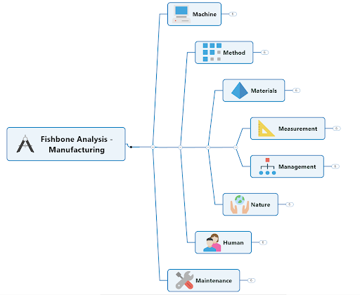

*Image:* (Leanne Armstrong, 2020)

- Flowcharts

A flowchart is an easy-to-understand diagram with a variety of applications. But you can use it to outline and examine how the steps of a flawed process connect. Made up of a few simple symbols linked with arrows indicating workflow direction, flowcharts clearly illustrate what happens at each stage of a process – and how each event impacts other events and decisions.

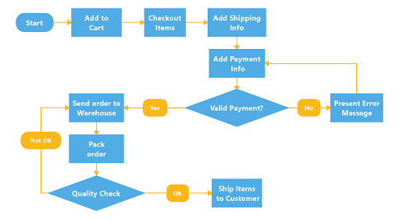

*Image:* (Leanne Armstrong, 2020)

- Strategy maps

Frequently used as a strategic planning tool, strategy maps also work well as problem mapping diagrams. Based on a hierarchal system, thoughts and ideas can be arranged on a single page to flesh out a potential resolution. Once you’ve got a few tactics you feel are worth exploring as possible ways to overcome a challenge, a strategy map will help you establish the best route to your problem-solving goal.

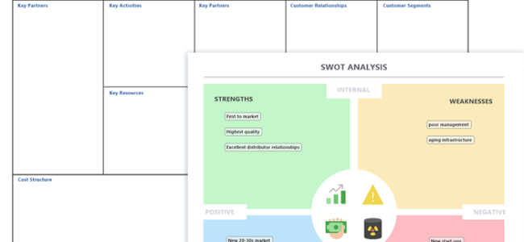

*Image:* (Leanne Armstrong, 2020)

- Mental maps

A mental map helps you get your thoughts about what might be causing a workplace issue out of your head and onto a shared digital space. Because mental maps mirror the way our brains take in and analyze new information, using them to describe your theories visually will help you and your team work through and test those thought models.

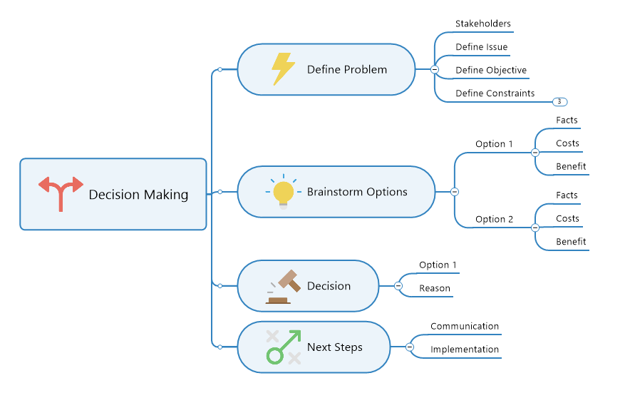

*Image:* (Leanne Armstrong, 2020)

- Idea maps

Idea maps let you take advantage of a wide assortment of colors and images to lay down and organize your scattered thought process. Idea maps are ideal brainstorming tools because they allow you to present and explore ideas about the best way to solve a problem collaboratively, and with a shared sense of enthusiasm for outside-the-box thinking.

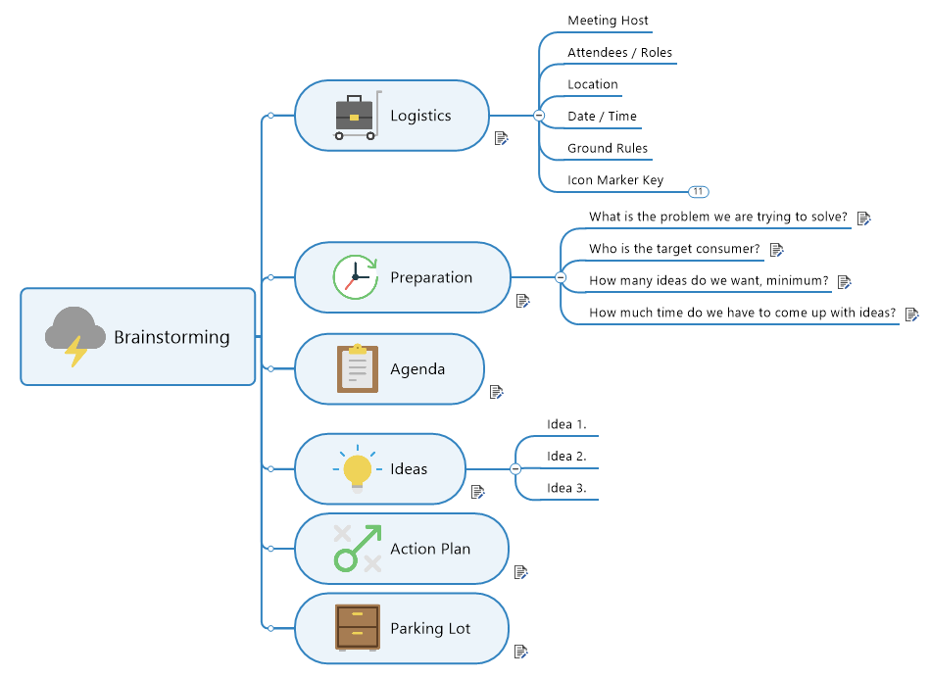

*Image:* (Leanne Armstrong, 2020)

- Concept maps:

Concept maps are one of the best ways to shape your thoughts around a potential solution because they let you create interlinked, visual representations of intricate concepts

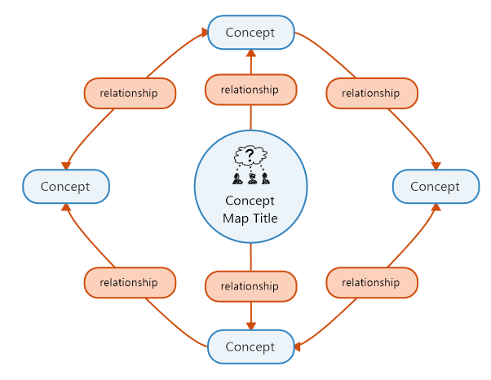

*Image:* (Leanne Armstrong, 2020)

### 4.2.3 Six Thinking Hats

White Hat - This hat deals with the facts and figures of the situation. Therefore when you and your team have this hat on, you need to be as objective as possible. Also, you need to engage in fact-gathering activities that ensure nothing but the relevant truths get to the table

Red Hat - Here, everyone deals with the intuition and emotion the facts and figures obtained have given them about the situation. You rely on your instinct and gut feelings to lead the way when you actively wear the red hat

Black Hat - You know it's the time to access and appreciate risk the moment you switch to the black hat. It calls for caution and ensures you fully understand the weaknesses in your strategy. Plus, it allows for recognition of inconsistencies in a plan

Yellow Hat - The yellow hat is responsible for accessing positivity and looking at the possibilities. As such, it is the hat of the optimist. When you have this on, you’re looking for opportunities for inside and outside sales in the market and how you can strategically drive new business

Green Hat - You and your team can shift to creativity mode with the green hat. It is natural to stick to what you already know. However, you need to explore uncharted territories and divert from old tactics. This helps you find out new ways of addressing problems

Blue Hat - The blue hat helps organize the entire decision-making and planning process. It's essential everyone, including the leader, also wears this hat to know the layout and infrastructure the whole group is using. Because without it, the strategy lacks structure, and this affects how the team achieves its expected objectives (Merrill, 2020)

## 4.3. Problems and solutions in the training event

* The first problem: During the training event on the day of meeting with the speaker, there were some students who did not interact, work separately, did not focus on the speaker's presentation, this would make the students not understand what the speaker shares
* The solution

We used “Six thinking hats” to solve this problem

* + White hat: The facts in this matter indicate that some students do not save, work alone, do not focus on the author's presentation, which affects the quality of the lecture
  + Red hat: Here we solved the problem by having members stand in the corners of the auditorium to observe, reminding students to focus, not working alone, and encouraging students to interact with the speaker
  + Black hat: The disadvantage of the solution above is that students feel constrained in the process of participating in the event when someone is always paying attention to their actions
  + Yellow hat: The above solution is work able to implement. It is effective to apply during the event process and this is also the most popular solution to improve the quality of events
  + Green hat: In addition to the above solution, there are many other solutions to solve the above problem, such as selecting attractive speakers and errors in the presentation process, creating more activities during the presentation. program so that the students do not get duplicated
  + Blue hat: My group consists of 5 members arranged as follows: 1 member is responsible for supporting the lecturer on the podium, the remaining 4 members are assigned to stand in 4 corners of the auditorium to observe and remind fellow students.
* The second problem: Power outage in the event

Includes human and mechanical causes: + Human causes: fixed outage schedule of the power company, unexpected power problems during the event + Causes of machinery: including subjective and objective causes such as devices with insufficient batteries, no charging devices, incompatible devices and damage to devices during the event

* 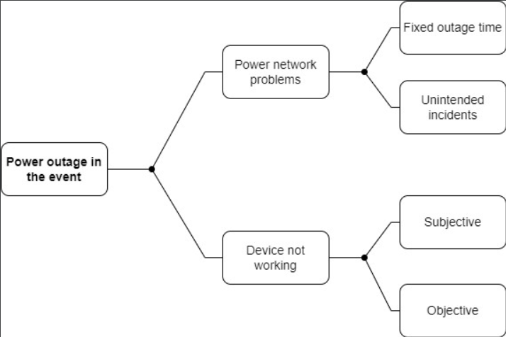
* The solution
  + To solve this problem, our group sent a member to rent a generator to supply electricity to the auditorium so that the presentation took place seamlessly without interruption
  + Minimize the risk of equipment damage, and always be prepared for all disruptions during the event.

# 5. DEMONSTRATE THAT CRITICAL REASONING HAS BEEN APPLIED TO A GIVEN SOLUTION (P4)

## 5.1. Definition and the importance of critical reasoning

### 5.1.1 Definition

According to (Chakraborty, 2020) Critical thinking is the ability to think clearly and rationally, understanding the logical connection between ideas. In essence, critical thinking requires candidates to use their ability to find the reason behind everything. Critical thinking is all about being an active learner rather than a passive recipient of information. A good critical thinker will question ideas and assumptions rather than accepting them as it is. They always seek to determine whether the ideas, arguments and findings represent the entire picture of any given statement or not. Besides critical reasoning is all about identifying, analyzing and solving problems systematically.

According to (Thomson, 2009) Critical reasoning is centrally concerned with giving reasons for one's beliefs and actions, analyzing and evaluating one's own and other people's reasoning, devising and constructing better reasoning. Common to these activities are certain distinct skills, for example, recognizing reasons and conclusions, recognizing unstated assumptions, drawing conclusions, appraising evidence and evaluating statements, judging whether conclusions are warranted; and underlying all of these skills is the ability to use language with clarity and discrimination. Critical reasoning is centrally concerned with giving reasons for one's beliefs and actions, analyzing and evaluating one's own and other people's reasoning, devising and constructing better reasoning.

### 5.1.2. Importance

According to (Thomson, 2009) Reasoning well is a skill that is valuable to anyone who wants to understand and deal with the natural and social worlds. Scientists need to reason well in order to understand the causes of phenomena. Politicians need to reason well in order to be able to adopt the right policies. But we cannot leave reasoning to scientists and politicians, because we all want to know whether what they tell us and what they prescribe for us is right. So reasoning well is an important skill for all of us.

## 5.2. Apply to a given solution

* Problem 1: During the training event on the day of meeting with the speaker, there were some students who did not interact, work separately, did not focus on the speaker's presentation, this would make the students not understand what the speaker shares

- Identify the problem: The lack of concentration of the students during the events

- Problem analysis: The lack of practice of students can occur in two directions, subjective and objective. Subjective because the speaker's lack attraction, have little interaction with students or are too boring

- Solution: To overcome this problem, our group will divide members to stand in the corners of the auditorium to observe and remind students to focus and not work alone and encourage the students to interact with the speaker

- Evaluate the solution: This is one of the solutions that can be temporarily fixed during the event.

* Problem 2: During this event, we had an electrical problem. When we were working with the projector on the slide, the auditorium suddenly lost power and all the systems went down

- Identify the problem: Power failure during the event

- Problem analysis: The cause of the power failure may be due to some unexpected incident leading to the power grid being cut off

- Solution: To solve this problem, my group sent a member to rent a generator to provide electricity for the auditorium

- Evaluate the solution: This is the most effective way to remedy and prevent power outages when power grid problems occur during the event.

# 6. PERFORMANCE EVALUATION

## 6.1. Team member’s roles

|  |  |  |
| --- | --- | --- |
| No. | Task | Person in charge |
| 1 | Decorate for the auditorium | Minh, Chinh, Tuan |
| 2 | send emails to inform students | Duy |
| 3 | Send invitations to speakers and lecturers | Duy, Chinh |
| 4 | The first day of event. The speaker presentation | All Members |
| 5 | The second day of event. The lecturer Nguyen Hung Dung training about “Data Design” part 1 | Minh |
| 6 | The third day of event. The lecturer Nguyen Hung Dung training about “Data Design” part 2 | Duy |
| 7 | The fourth day of event. The lecturer Tran Thi Anh Phuong training about “Time management skill” | Kiet |
| 8 | The fifth day of event. The lecturer Tran Thi Anh Phuong training about “Communication skill” | Chinh |
| 9 | The sixth day of event. Summarize the training event | All members |

## 6.2. My contribution

* **Do Huu Duy:** In this Assignment, my job is to do part 1 and 3 of the assignment. I tried to do well and complete the assigned work well and on time. In addition, I also contributed to the preparation of the event such as send emails to inform students and Send invitations to speakers and lecturers. Besides, during the event take place I also support the lecturer in teaching process.
* **Luu Pham Anh Kiet:** In this Assignment, my job is to do part 4 of the assignment. I tried my best to complete my assigned task. In this assignment, I am in charge of sending invitations to the trainers and responsible for this training.
* **Huynh Quoc Tuan:** In this Assignment, my job is to do part 2 of the assignment. In this assignment, I am responsible for decorating the auditorium. I also tried my best to complete the assigned tasks on time.
* **Truong Quang Minh:** In this assignment, my job is to do parts 5 and 6 of the assignment. I tried to do well and complete the assigned work well, on time. In addition, I also contributed to the preparation of the event such as decorating the auditorium, assisting the lecturer during the event, and taking part in summarizing the entire event process.
* **Nguyen Nhat Chinh**: In this assignment, I was assigned to do part 3 with Duy and reformatted the exercise so that it was in the correct format. I tried to complete my work on time allotted. From planning your training, creating a timeline, decorate for the auditorium, support the lecturer on fifth day and identifying the importance of time management skills.

# 7. Conclusion

In this report, we have fulfilled the requirements of the assignment clearly. We have discussed together and come up with an event to work together, but in this report, we have certain difficulties. first, this is our first time doing an event, we are inexperienced. Secondly, my team members have a lot of different opinions and some of them disagree with each other, so there are cases where members of the group have been friction with each other, but we reminded each other static and discussion to come up with the final result. However, through this report, my team members have learned quite useful knowledge about how to manage time, how to communicate well, how to respond and solve problems. Besides, in this report, we helped students understanding about the importance of soft skill. Helping them equip themselves with important skills. We train in Database Design to give students an overview of this subject, helping them understand the basics of this subject so that they can be more solid when studying the subject at the specialized stage. For our team, we understand the importance of skills such as teamwork skills, time management skills, and problem-solving skills. During the event, we encountered a problem and we applied problem-solving skills to solve it. From there, we understood the importance of problem-solving skills and equipped us with it.

# 8. Critical evaluation

* The first member: Do Huu Duy
* Strengths
* I am able to respond and solve problems well, I am confident about this in me
* I know, how to manage time well. I completed all assign tasks on time.
* Weakness
* I am a quiet person so I don't talk so much when working with my team members. I think, this is my weakness and I need to improve
* I am often distracted when doing something and this sometimes makes my work process long and of poor quality.
* Improvement
* I have to be more open-minded when working with my team and actively come up with idea ideas
* I have to keep up the spirit to concentrate on work and choose a quiet place to work to avoid distractions.
* Expectation score
* In this assignment, I expect that I will get an M score.
* The second member: Truong Quang Minh
* Strength:
* Solve problems quickly but still have certain accuracy. This is a skill that I am working on
* Good document search and document selection skills. This is an essential skill in doing homework.
* Weakness
* I don't really manage my time well and often waste it. This is my biggest weakness
* Communication skills are not good. She is often embarrassed, shy and rarely communicates with other members of the group.
* Improvement
* I need to manage my time better by making a schedule and taking it seriously
* Need to be more open to those around, try to get along with people to improve communication skills.
* Expectation score
* In this assignment, I expect that I will get an M score
* The third member: Nguyen Nhat Chinh
* Strength
* Vibrant, sociable with everyone, can understand and share with friends in the group. Always coming up with new and original ideas
* Weakness
* In terms of communication, due to limited language, it is difficult to explain clearly to everyone
* Improvement
* It is necessary to cultivate more knowledge about communication and especially language so that the sentences are easy to understand and express ideas to people
* Expectation score
* In this assignment, I expect that I will get an M score
* The fourth member: Luu Pham Anh Kiet
* Strength
* Enthusiastically help my friends to the best of my ability. I think this is quite a necessity in teamwork
* Acquire and retain knowledge well. This is an advantage that I am quite proud of
* Weakness
* I am quite lazy and have not arranged a reasonable time in studying and working. This is a huge weakness
* I am also afraid of crowds and afraid to communicate. I will try to fix it soon.
* Improvement
* I need to pay more attention to my study time, arrange a reasonable schedule and do them more scientifically
* Sociable, more open with friends around so that I am no longer shy when interacting with strangers, that will make my communication skills improve.
* Expectation score
* In this assignment, I hope I will reach the M point
* The fifth member: Huynh Quoc Tuan
* Strength
* Respect and friendliness to everyone around
* I’ve always liked being balanced. When I work, I want to work hard. And outside of work, I like to engage in my personal activities such as billiard and fishing.
* Weakness
* Besides strengths, I also see some weaknesses of myself such as limited foreign language ability
* Management skills and work arrangement are limited.
* Improvement
* I need to improve my English every day, exchange and learn more about English
* I need to manage my time and organize my work properly.
* Expectation score
* In this assignment, I expect that I will get an M score.

# References

Armstrong, L., 2020. *problem-solving-tools.* [Online]   
Available at: https://blog.mindmanager.com/blog/2020/07/07/202007problem-solving-tools/  
[Accessed 27 1 2022].

Chakraborty, T., 2020. *testbook.com.* [Online]   
Available at: https://testbook.com/learn/critical-reasoning/  
[Accessed 17 2 2022].

cleverism, 2022. *verbal-communication.* [Online]   
Available at: https://www.cleverism.com/skills-and-tools/verbal-communication/  
[Accessed 25 1 2022].

getuplearn, 2021. *what-is-verbal-communication.* [Online]   
Available at: https://getuplearn.com/blog/verbal-communication/#what-is-verbal-communication  
[Accessed 25 1 2022].

harappa, 2021. *verbal-communication-and-its-types.* [Online]   
Available at: https://harappa.education/harappa-diaries/verbal-communication-and-its-types/  
[Accessed 25 1 2022].

IBMR, A., 2020. *what-are-communication-skills-types-and-importance-of-communication-skills.* [Online]   
Available at: https://www.asmibmr.edu.in/blog/what-are-communication-skills-types-and-importance-of-communication-skills/#  
[Accessed 15 2 2022].

indeed, 2021. *communication-skills.* [Online]   
Available at: https://in.indeed.com/career-advice/resumes-cover-letters/communication-skills  
[Accessed 25 1 2022].

indeed, 2021. *nonverbal-communication-skills.* [Online]   
Available at: https://www.indeed.com/career-advice/career-development/nonverbal-communication-skills  
[Accessed 25 1 2022].

instagantt, 2022. *instagantt.* [Online]   
Available at: https://instagantt.com/project-management/what-is-problem-solving-definition-and-examples  
[Accessed 27 1 2022].

kepner-tregoe, 2022. *what-is-problem-solving-and-why-is-it-important.* [Online]   
Available at: https://kepner-tregoe.com/blogs/what-is-problem-solving-and-why-is-it-important/  
[Accessed 27 1 2022].

Leanne Armstrong, 2020. *mindmanager.* [Online]   
Available at: https://blog.mindmanager.com/blog/2020/07/07/202007problem-solving-tools/  
[Accessed 27 1 2022].

M.S Sam, 2022. *problem-solving.* [Online]   
Available at: https://psychologydictionary.org/problem-solving/  
[Accessed 27 1 2022].

M.S, S., 2022. *problem-solving.* [Online]   
Available at: https://psychologydictionary.org/problem-solving/  
[Accessed 27 1 2022].

medical-dictionary.thefreedictionary, 2022. *medical-dictionary.thefreedictionary.* [Online]   
Available at: https://medical-dictionary.thefreedictionary.com/Problem-solving  
[Accessed 27 1 2022].

Merrill, E., 2020. *https://www.smestrategy.net/blog/using-the-6-thinking-for-strategic-planning.* [Online]   
Available at: https://www.smestrategy.net/blog/using-the-6-thinking-for-strategic-planning  
[Accessed 16 2 2022].

meterial, G., 2022. *flm.greenwich.edu.vn.* [Online]   
Available at: https://flm.greenwich.edu.vn/gui/role/guest/ListScheduleSyllabus?subjectCode=sL89VRvQKyoHKKH1BYndpw==&SessionNo=m/3vcUZdTzpNcnvRqSgvZw==  
[Accessed 25 1 2022].

resume, 2021. *non-verbal-communication.* [Online]   
Available at: https://www.resume.com/career-advice/career-development/non-verbal-communication/  
[Accessed 25 1 2022].

resumelab, 2022. *communication-skills.* [Online]   
Available at: https://resumelab.com/resume/communication-skills  
[Accessed 25 1 2022].

Sadiya, D., 2019. *youthincmag.com.* [Online]   
Available at: https://youthincmag.com/problem-solving-skill  
[Accessed 16 2 2022].

Thomson, A., 2009. *Philosophy.* 3rd ed. s.l.:Routledge.

Valdellon, L., 2017. *problem-solving-techniques.* [Online]   
Available at: https://www.wrike.com/blog/problem-solving-techniques/  
[Accessed 27 1 2022].

wikipedia, 2022. *Nonverbal_communication.* [Online]   
Available at: https://en.wikipedia.org/wiki/Nonverbal_communication  
[Accessed 25 1 2022].